ASHA MOHAMED NOOR
DAY 5 ASSIGNMENT
TECHNICAL WRITING FOR SOFTWARE DOCUMENTATION

A) User Manual Procedure (20 minutes)

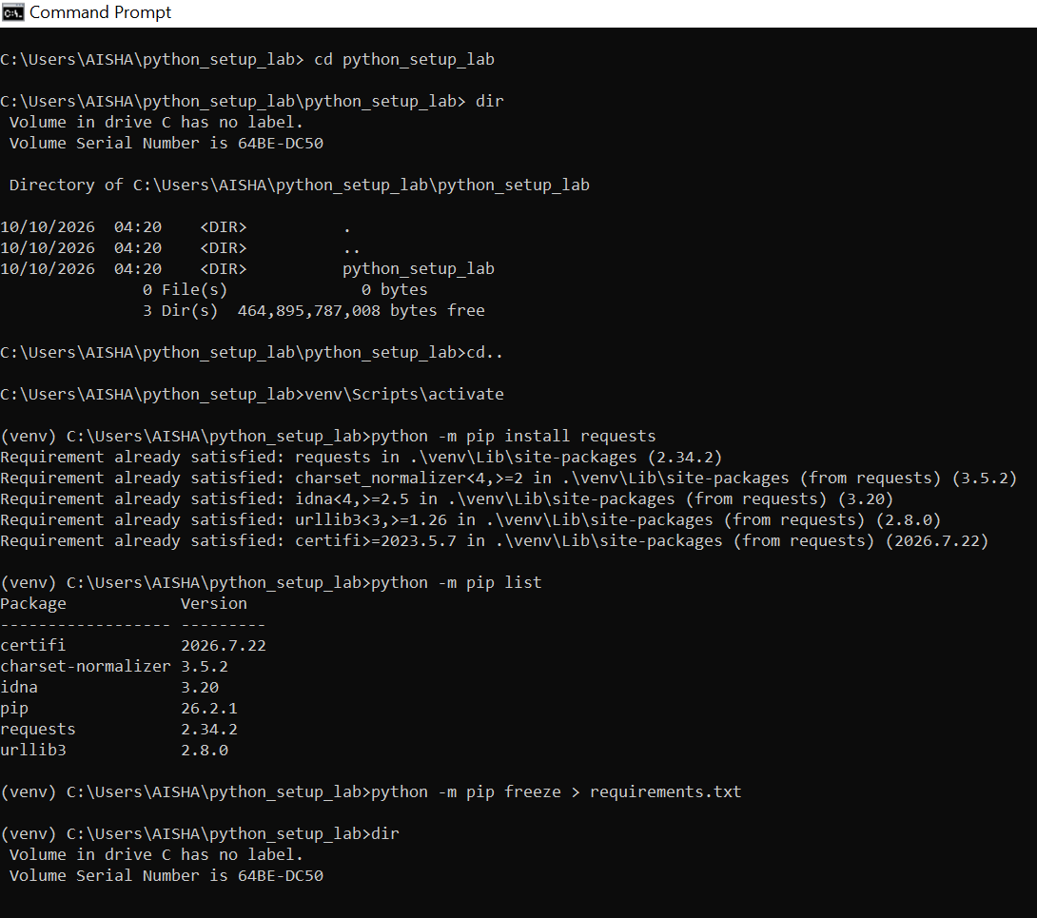

B) API REFERENCE ENTRY: CREATE A NEW TASK

1. Introduction
An API allows different software applications to communicate with each other and exchange information. In a project management application, users need to create tasks, assign them to people, and set deadlines.
This API endpoint allows a logged-in user to create a new task in a project. The user provides the task name, an optional description, the ID of the person responsible for the task, the due date, and the priority level. The server checks the information before saving the task.

2. HTTP Method and Endpoint Path
HTTP Method: POST
Endpoint Path: /api/v1/projects/{projectId}/tasks
The POST method is used to create a new task. The endpoint shows where the request should be sent. The {projectId} represents the ID of the project where the task will be added.
For example:
/api/v1/projects/proj_101/tasks
Here, proj_101 is the ID of the project.

3. Request Parameters
Request parameters are the details sent to the server when creating a task.

3.1 Path Parameters
Parameter | Data type | Required | Description
projectId | String | Yes | Identifies the project where the new task will be created.

3.2 Query Parameters
This endpoint does not use query parameters because the required task information is sent in the request body.

3.3 Request Body Parameters
The request body contains the details of the task in JSON format.
Parameter | Data type | Required | Description
title | String | Yes | The name of the task. It must contain 1–200 characters.
description | String | No | Gives more information about the task. It can be left out if it is not needed.
assigneeId | String | Yes | The ID of the user who will be responsible for completing the task.
dueDate | String (date) | Yes | The deadline for the task, written in YYYY-MM-DD format.
priority | String | Yes | Shows the importance of the task. The accepted values are low, medium, and high.

4. Request Headers
Headers provide additional information that the server needs to process the request.
Header | Required | Description
Authorization | Yes | Provides the user's access token to verify their identity.
Content-Type | Yes | Specifies that the request body contains JSON data.
Accept | Yes | Tells the server that the client expects a JSON response.
Example:
Authorization: Bearer <access_token>
The user must replace <access_token> with a valid access token.

5. Example Request
For example, a user wants to create a task called "Complete Database Assignment". The following request shows how the application sends the task details to the server.
HTTP request:
POST /api/v1/projects/proj_101/tasks HTTP/1.1
Host: api.example.com
Authorization: Bearer <access_token>
Content-Type: application/json
Accept: application/json
Request body (JSON):
{
"title": "Complete Database Assignment",
"description": "Design the ER diagram and create the database tables.",
"assigneeId": "user_205",
"dueDate": "2026-10-20",
"priority": "high"
}
In this example, the task is assigned to user user_205, has a deadline of 20 October 2026, and is marked as high priority.

6. Successful Response
When the server creates the task successfully, it returns the status code 201 Created. This means the task has been saved, and the server sends back its details.
Example response body (JSON):
{
"id": "task_501",
"projectId": "proj_101",
"title": "Complete Database Assignment",
"description": "Design the ER diagram and create the database tables.",
"assigneeId": "user_205",
"dueDate": "2026-10-20",
"priority": "high",
"status": "pending",
"createdAt": "2026-10-11T18:30:00Z",
"createdBy": "user_102"
}

Explanation of the Response Fields
Field | Data type | Description
id | String | The unique ID generated for the new task.
projectId | String | Identifies the project where the task was added.
title | String | Shows the task name.
description | String | Provides more information about the task.
assigneeId | String | Identifies the user assigned to the task.
dueDate | String (date) | Shows the deadline for completing the task.
priority | String | Shows the importance of the task.
status | String | Shows the task's current status. A new task starts as pending.
createdAt | String (date-time) | Records when the task was created.
createdBy | String | Identifies the user who created the task.

7. HTTP Response Codes
Response codes tell the application whether the request was successful or whether a problem occurred.
Status code | Name | Explanation
201 | Created | The task was created successfully.
400 | Bad Request | Some required information is missing or incorrectly provided.
401 | Unauthorized | The user has not provided a valid access token or the token has expired.
403 | Forbidden | The user is logged in but does not have permission to create tasks in the project.
404 | Not Found | The project or assigned user cannot be found.
409 | Conflict | The request conflicts with an existing resource or project rule.
415 | Unsupported Media Type | The request uses a data format that the server does not support.
422 | Unprocessable Entity | The request is correctly formatted, but the information does not meet a business rule. For example, the assigned user may not belong to the project.
429 | Too Many Requests | The user has sent too many requests within a short period.
500 | Internal Server Error | An unexpected problem has occurred on the server.
503 | Service Unavailable | The server is temporarily unavailable.

8. Validation Rules
Before saving the task, the server checks that the user is logged in and has permission to create tasks in the selected project. It also checks that the project and assigned user exist, the title is not empty, and the due date is valid.
The priority must be low, medium, or high. The request must also contain valid JSON data.
If any required information is incorrect, the server returns an appropriate error response and does not create the task.

9. Conclusion
In conclusion, this API endpoint allows a logged-in user to create a new task in a project management application. It uses the POST method to send task information to the server in JSON format. The server checks the information, saves the task, and returns a success response when the task is created. This documentation helps developers understand how to use the endpoint and what responses they can expect.

